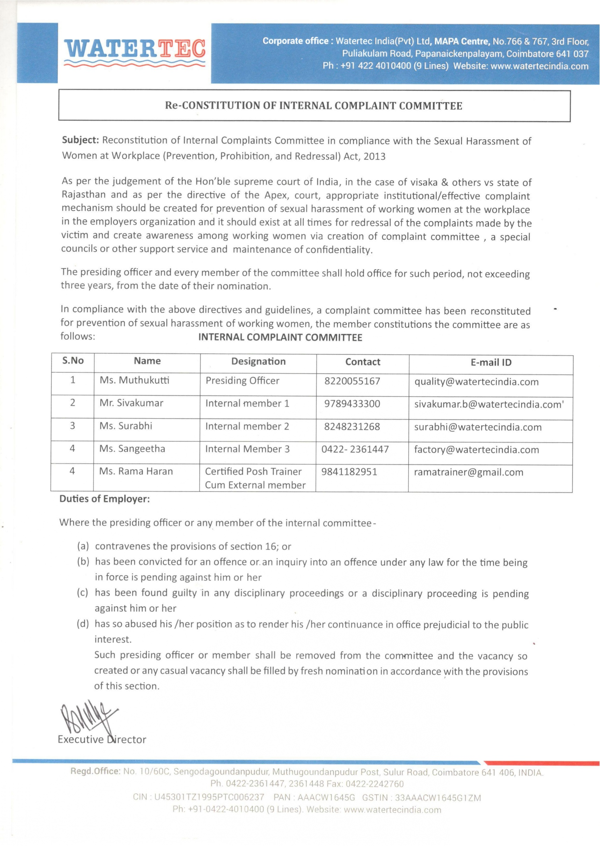

Online Complaint form
- Your Name and Designation:
- You belong to which department?
  - Your location:
- Employee id no if any:
- Mobile No (WhatsApp Number):
- Gender: Male (ஆண்)Female (பெ ண்)Thirdgender (திருநங்கை )
- You are Complaining on whom?
- Title of Complaint:
- Date and Time of the last incident :
- Mention the details of number of incidents:
- Did you voice that you are not comfortable with their verbal/Non verbal/Physical behavior:
- Complaint (in detail):

- Evidence for Complaint:
- WhatsApp/Text message/Email/Photo/Audio/Video recording if any:
- Details of any persons contacted/Shared by the aggrieved woman after the incident (If any):
- Your Request against the complaint (in detail):
- Files submitted:
- Declaration *
- Signature
- Date:

